Physics and Astronomy

Communiqué

Fall 2020

News from the Chair

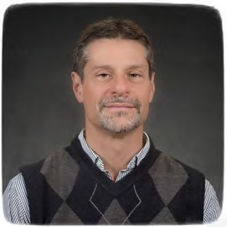

Dear Alumni, Colleagues and Friends,
I hope that this newsletter finds you healthy and in good spirits. To say that 2020 is an unprecedented year would be an understatement as it will be a year for the history books where we will record several parallel challenges that include reinventing the way we teach our courses, reconfiguring the way we pursue our research and professional interactions, and dealing with a significant budget contraction.

Nevertheless, there are inspiring glimmers of good news at hand. While many universities have encountered a significant decline in enrollment, the overall enrollment at the University of Missouri increased by 3.5% over the past year for a total enrollment of 31,105 students as of Oct. 1, 2020. MU also set a high record for the student retention rate of 89.4% this fall, meaning that nearly 9 out of 10 MU freshmen have returned as sophomores. The Department of Physics and Astronomy, in particular, has seen an even stronger enrollment increase of 14% in the courses that we offer, with 1879 students enrolled among all
courses offered by our Department in Fall 2020. This increase is mainly attributed to our large‐enrollment introductory courses while the number of undergraduate physics majors (104) and graduate student population (47) remain relatively constant.
When the full realization of the pandemic was apparent in March, MU, like other universities, pivoted to all online instruction. Thanks to the extensive experience of some of our faculty with online teaching, this transition was remarkably smooth for our large‐enrollment physics courses.
The pandemic disrupted our research and work slowly returned to our research labs towards the late spring and early summer. As the fall approached, there was significant trepidation about how we would conduct the business of teaching. The University adopted a combination of in‐ person, on‐line and hybrid modes of instruction while employing the use of face masks and reconfigured classrooms to significantly reduce the density of students. While the student infection rate was high in the early part of the fall semester, it has dropped precipitously in recent weeks. The number of faculty infections has been extremely low, pointing to the effectiveness of the strategies used to minimize viral transmission in the classrooms and our buildings.
Despite social distancing, our department was host to a National Science Foundation sponsored workshop, Precision Nanoscale Patterning and Characterization – From Cybernetic Proteins to Nanoengineered Quantum Devices, held Aug. 5‐7, 2020.
This virtual workshop, conducted via Zoom, was the creation of Prof. Suchi Guha and Prof. Gavin King who had proposed it to the NSF based on their interest in ice lithography. The workshop assembled over 90 researchers nationally and internationally to discuss the next generation of sub‐5 nm nano fabrication and characterization.
In other news over the past year, I am pleased to congratulate Prof. Silvia Bompadre who was Promoted to Associate Teaching Professor. Dr. Bompadre is our Director of Undergraduate Studies (DUGS) and she is actively developing a mentoring program for our physics majors. As part of that effort, we would welcome our Alumni to help connect our undergraduates with career paths in industry.
I also congratulate Prof. Gavin King who was promoted to Professor. As one of our experimentalist faculty, Gavin has developed ultra‐stable atomic force microscopy to investigate single‐ molecule biophysics. I am grateful to Prof. Suchi Guha for taking on the role of Director of Graduate Studies (DGS) after I stepped down from that position to become department chair. We have a new departmental initiative, led by Prof. King in collaboration with the DGS and DUGS, to aggressively engage in outreach in order to expand our recruiting effectiveness of both undergraduate and graduate students While the pandemic has introduced barriers, we have already jumpstarted this initiative with virtual outreach.
(continued on next page)

The department is also very proud to recognize the major achievements of Prof. Shi-Jie Chen and Prof. Xiaoqin Zou who have separately been awarded a prestigious R35 (MIRA) grant from the National Institutes of Health ($2.2M and $1.9M, respectively, for 5 years). This type of grant is awarded specifically to experienced investigators with an outstanding record of research productivity and it aims to provide long‐ term support. Finally, I regret to report that Prof. Se Kwon Kim, Vineyard Assistant Professor of Theoretical Physics, left our department to take a position at the Korea Advanced Institute of Science and Technology (KAIST) in South Korea. We wish Se Kwon and his family all the best.
I want to extend a special “thank you” to Prof. Sashi Satpathy for his six years of outstanding service as our department chairman, which ended July 31. I admire and appreciate Sashi’s dedication to the department and his diligent work to improve it. During his time as chair, Sashi expanded the use of committees and concomitantly improved the self‐governance
of the department. It is noteworthy that he kept the financial standing of the department strong during a time of significant budget cuts and he managed to find the resources to recruit five new faculty to our department, nearly one per year. The ability to recruit new faculty is particularly important in light of the many recent retirements that we have had and it is my hope that we can maintain some of this recruiting momentum despite the looming budget contraction.
In closing, I want to thank the faculty, staff and students for their extraordinary efforts to maintain a sense of normalcy by continuing their hard work and their academic pursuits in these unusual times.
With best regards,
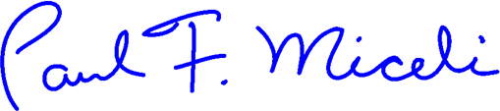

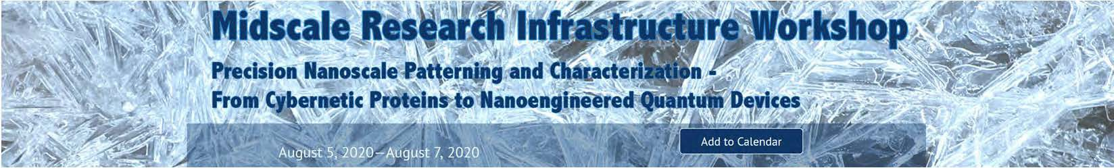

Professors Suchi Guha and Gavin King hosted an NSF-sponsored virtual workshop at MU August 5-7, 2020 on Precision Nanoscale Patterning and Characterization.

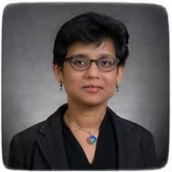
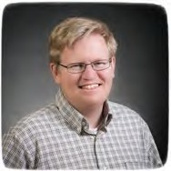
The workshop aimed to establish a platform for exchanging ideas in recent innovations and trends in sub‐5 nm nanofabrication and characterization techniques by bringing together scientists and researchers from multidisciplinary areas and seeking a path forward towards advancing 3D nanofabrication, additive manufacturing, and nano‐electronic devices. The workshop was highly successful with participation from more than 90 individuals from the US and Europe.

For more details, see our website ( https://physics.missouri.edu/)

Prof. Suchi Guha Prof. Gavin King

MU researchers gain a greater understanding of cell behavior by developing theoretical model of how proteins work with cell membranes (MU News Bureau)

(Story Contact: Eric Stann, 573‐882‐3346, stanne@missouri.edu)

Prof. Ioan Kosztin (theoretical physics) partnered with Prof. Gavin King (experimental physics) to develop a theoretical model that shows there is more than one way a protein can break free of the membrane involving several different pathways. They discovered that the protein‐membrane interaction can exhibit a “catch‐bond” behavior. The researchers hope this discovery will provide a foundation for future studies on signaling pathways in cells and how drugs vary cellular functions.

The study, “Multiple stochastic pathways in forced peptide‐lipid membrane detachment” was published in Scientific Reports. A detailed article on their innovative research by can be found on our website: https://physics.missouri.edu/

Thoughts from our outgoing chair

It seems like yesterday, when one evening six years ago, I enlisted the help of my dear wife Namita to decorate my new Chair’s office. Among other things, we purchased a life‐size statue of Lord Buddha and placed it prominently next to the meeting table in my office with the hope that it would subdue the materialistic desires in the faculty, when they come to request resources from the department. Not sure if that worked, but the statue did help in calming my nerves during stressful days, of which there were many.
During the last six years, the University faced many difficult problems, beginning with the 2015 student activism followed by dwindling student enrollment and continual budget cuts year after year. In spite of this, we did manage, quite miraculously, to hire five new faculty members thanks to the strong support from the administration and excellent work by the faculty search committees. Despite the budget cuts, the department's finances remained in relatively good shape thanks to the four‐fold increase in our online teaching income, full credit for which goes to the efforts of our non‐tenure track faculty. However, the original plan of growing our graduate program with that money remained elusive, since the money had to be used to cover the budget cuts. We are grateful to our alumni and friends for their generous gifts to the department that kept many activities going in spite of the budget woes.
We are deeply indebted to Ron and Catherine Rangel Boain for their estate gift to the department announced last year, which will go a long way in making our department stronger. Among other activities, we held the first ever Alumni Reunion in the department in 2016, which was a successful event attended by about a hundred alumni. I hope that we can continue the event periodically in the future. According to the ranking of the US News & World Report, we went up from #95 in 2014 to #91 in 2018 (the most recent year for which data is available) among the physics departments in the country. Admittedly, this is a small improvement, however it does show that our trajectory is in the right direction. I believe we accomplished this by hiring good faculty and increasing the research productivity of the existing faculty. I believe that we can all increase our journal publications, since quite a few times many of us don't publish completed research, thinking that it is simple or mundane work. I can relate from my own research experience that some papers that I did not think much of at the time, and published anyway only because students were involved, eventually became quite well received despite my initial skepticism.
I am deeply grateful to the faculty as well as the administration for their strong support and cooperation during my tenure. Very rarely faculty turned down my request for help. I will be amiss if I did not mention some people by name here. As Associate Chair, Dorina Kosztin performed many teaching tasks for the department such as the Curriculum committee work and student relations, which freed up my time to focus on things that only the Chair can do. Her firm approach to student and parent complaints made sure that they rarely came to the Chair’s level.
As Director of Graduate Studies (DGS), first Carsten Ullrich and then Paul Miceli skillfully guided the graduate program, starting from admission of new students to following up with them throughout their stay at MU. The DGS is probably the most important position after the Chair, since the department’s research success is strongly tied to how good graduate students we can get. Silvia Bompadre as the Director of Undergraduate Studies took care of the undergraduate students single‐ handedly. In addition, there was a myriad of committees, too many to mention here, which did a variety of work in the department.
I thank the numerous faculty members for the “corridor conversations,” which shaped my thought process. Often the faculty members with offices close to my office suffered the most, and occasionally I would call the faculty at home to seek their input. So hiding at home didn’t help!
The Physics staff did an excellent support job and under Matt Laffey we finally solved many lingering accounting problems in the department, which had built up over several decades!
I want to express my deepest gratitude to all of you, the faculty, the staff, Physics Leaders, the Deans and upper administrators, for your support, cooperation, and above all for your friendship, some of which are decades long! I remain eternally optimistic about the future of the department. I am delighted to see that our very capable and esteemed colleague, Paul Miceli, has come forward to lead us for the next many years and I wish him the very best in his work to make our department better.
A difficult part for me during the last six years was simply that the Chair had to be available round the clock for the faculty, students, and the administrators in case any issues pop up. Now that I do not have those constraints, there are so many things apart from research and teaching that I hope to be able to do. Perhaps I will take a sabbatical leave next year (COVID killed any such aspirations this year), do some traveling including visiting the grand kids in California, and do a lot more meditative bicycling on our very beautiful Katy Trail.

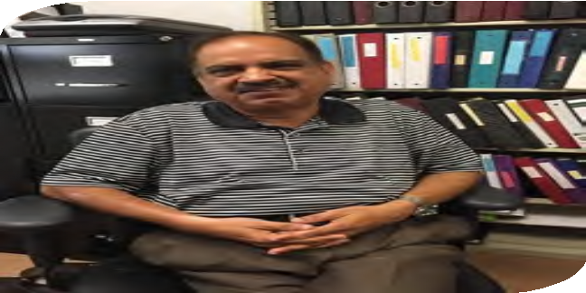

Wishing everyone great success and happiness in the years to come,
Sincerely,
Sashi Satpathy
Ex‐Chair and
Curators’ Distinguished Professor

Undergraduate News and Accomplishments

Society of Physics Students (SPS)
Our Society of Physics Students (SPS) Chapter was recognized
as a 2019 Distinguished Chapter by the National Council for “your tireless efforts to enrich the SPS community. It is because of your dedication and commitment to the SPS mission and vision that we are able to foster such a strong SPS community. “ All chapter award winners will be recognized on the Outstanding Chapter Award page for SPS; we are proud of our students!
(https://www.spsnational.org/awards/outstanding‐chapter)
SPS is meeting over Zoom this fall semester and has been
holding meetings every other Monday at 4 PM. Meetings cover anything from research to random topics in physics to courses offered in the department. Their most recent meeting was October 12th, where they played Physics Pictionary over Zoom. Whenever there isn’t a global pandemic, activities usually involve liquid nitrogen ice cream, pizza movie nights, and physics jeopardy.
Submitted
by
Ben
Krewson,
SPS
Vice‐President.
Sean Burke is the SPS president.

Sigma Pi Sigma – Honors Society (ΣΠΣ)

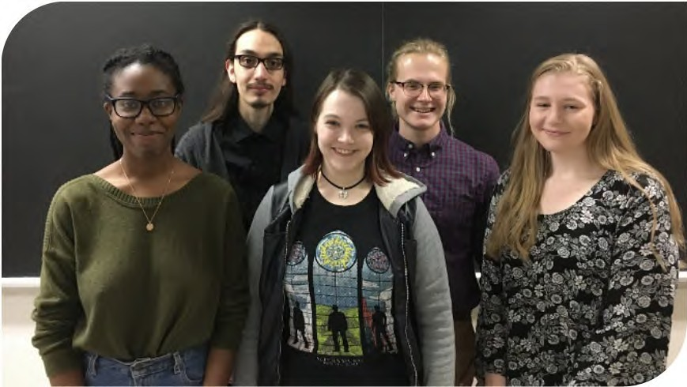
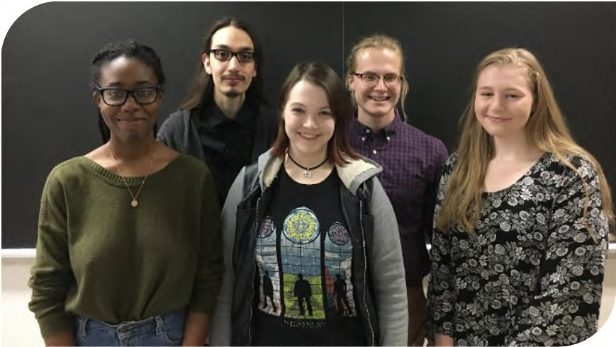
The 2019‐2020 school year was very successful for the Mizzou chapter of Sigma Pi Sigma! Sigma Pi Sigma hosted monthly meetings which were open to all undergraduates, with the purpose of encouraging motivated students to pursue research and internship opportunities. These meetings involved research presentations by some of our very own members, informational sessions on how how to prepare for a career fair, how to create a successful resume, an exploration of how to apply graduate school, and job prospects outside of physics, namely with the Navy Nuclear Program.

Additionally, last year’s president, Blake Goehman, led an induction ceremony where we welcomed our five new members: Lauryn Williams, Nicolas Bohorquez, Erica Dykes, Phillip Hegeman, and Cierra Presson.

The main goal of Sigma Pi Sigma this year is going to be to encourage our members to seek out professional opportunities by sharing advice and what we wish we had known about the application process.

I believe this is especially important now given how COVID has changed how we are involved in research and internships in an increasingly online world. We also look forward to expanding Sigma Pi Sigma further when we welcome new inductees in the spring.
Submitted by Matthew Snyder, President Sigma Pi Sigma. Cierra Presson is the Vice‐President.

Sigma Pi Sgma 2020 Inductees (from left): Lauryn Williams, Nicolas Bohorquez, Erica Dykes, Phillip Hegeman, Cierra Presson

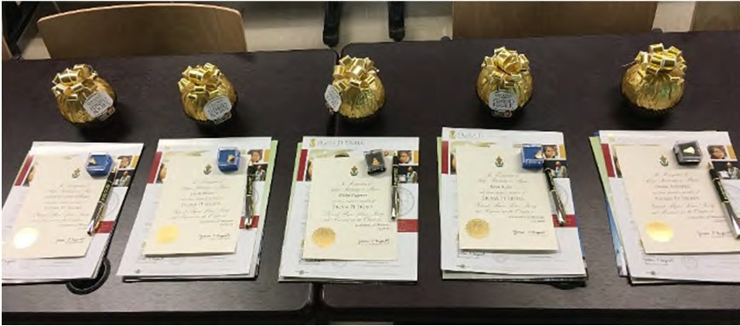
Sigma Pi Sigma induction packages

MUSAS –MU Astronomy Club
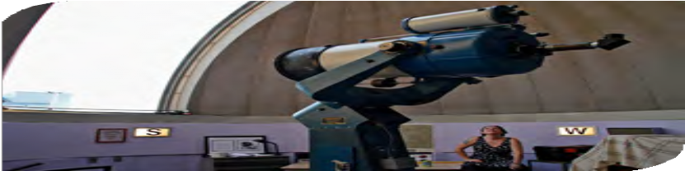

MU Student Astronomical Society (MUSAS) is still going strong! Our meetings are online via Zoom every other week on Wednesday nights from 6:15‐7:15pm. To find more information check out our Astronomy club engage page at: https://missouri.campuslabs.com/engage/organization/mu‐student‐astronomical‐society Members typically assist with operation of the Laws Observatory open operation on Wednesday nights, but the Observatory is unfortunately closed until further notice due to COVID‐19. Other club activities include stargazing nights outside of town, and movie nights (with an out of this world theme)! The MUSAS is open to any MU student.
Submitted by Anna Merkel, MU Astronomy Club President Emma Burton is the Vice‐president
Laws Observatory, normally open to the public thanks to the efforts of the Mid‐Missouri Astronomy Association and MUSAS, has been closed since March.

Congratulations to our graduating physics majors!

FALL 2019

Ethan Calfee Haojia Chi
Daniel Kim, emphasis in Biophysics Wesley Mundil, emphasis in Astronomy Jared Prejna
Claire Rosentreter, emphasis in Astronomy
Zachary Valleroy, Summa Cum Laude, Department Honors

SUMMER 2020
Jared Kester, emphasis in Astronomy
Tyler Kling, emphasis in Astronomy

SPRING 2020
Erica Dykes, emphasis in Astronomy

Blake Goehman
Phillip Hegeman, Magna Cum Laude, General Honors
Patrick Hoback, Summa Cum Laude
Brian Hybben, Jr., Summa Cum Laude, emphasis in Astronomy
Maxwell Metter, emphasis in Astronomy
Joshua Miles, Summa Cum Laude, emphasis in Materials Science, Department Honors
Connor Penrod, emphasis in Astronomy

Nicholas Staver Nicholas Waters

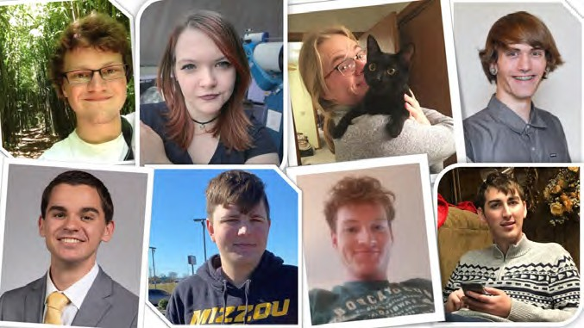
Top left: Jared Kester, Erica Dykes, Phillip Hegeman, Brian Hybben Bottom left: Josh Miles, Blake Goehman, Connor Penrod, Tyler Kling
Departmental Honors requires > 3.5 GPA in physics courses, completion of 6 credit hours of research, and a publication or presentation (oral or poster). A Certificate in General Honors from the MU Honors College requires students to complete 24 hours of courses for honors credit and maintain a
3.5 cumulative GPA.
To receive Latin honors from our College of Arts and Science requires at least 54 of the student’s last 60 hours at MU and:

  - – 3.799 GPA for Cum Laude
  - – 3.899 GPA for Magna Cum Laude
  - – 4.0 GPA for Summa Cum Laude

Graduate Students – News and Accomplishments

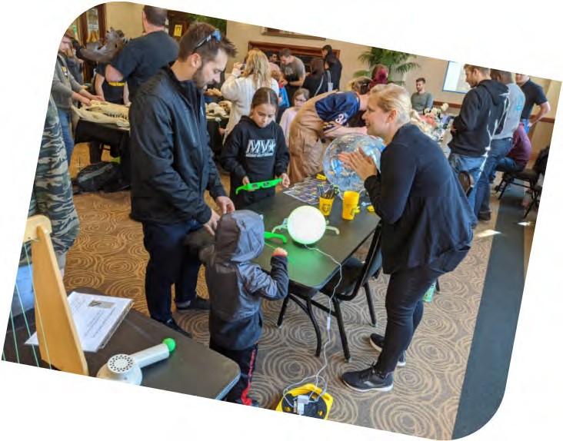
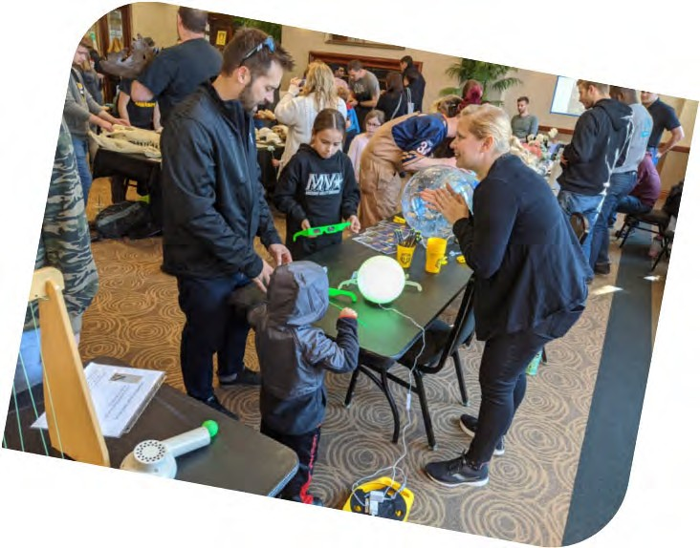
PAGSA NEWS
In the 2019‐20 school year, the Physics and Astronomy Graduate Student Association (PAGSA) held monthly meetings as well as journal clubs, even continuing to do so online when the COVID‐19 pandemic hit and kept us away from campus. we successfully ran a gift run for a young boy and participated in public outreach event including the Columbia Young Scientist Exposition in February which had over 600 attendants!
Submitted by Jared Williams, PAGSA president

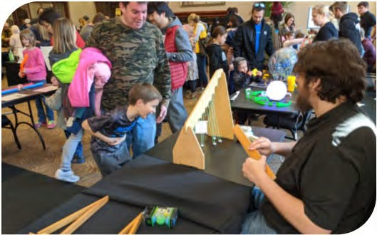
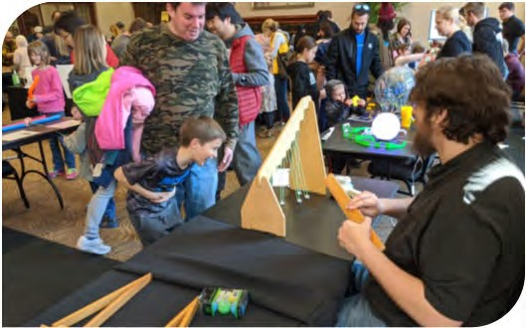
Graduate students Lisa Shepard and Charles Menzer interact with young aspiring scientists in February.


Lisa Shepard wins the Chambliss Astronomy Achievement Student Award
Congratulations to graduate student Lisa
Shepard for winning the Chambliss Astronomy Achievement Student Award. This prestigious award is given to recognize exemplary research by students who present at meetings of the American Astronomical Society.
Awardees are honored with an engraved gold‐ plated brass Chambliss medal. Lisa was one of six graduate student medalists (out of 125 entrants) awarded this honor at the 235th AAS meeting.
Earlier this year, Lisa was also selected to
become a 2020 AAS Astronomy Ambassador. The AAS Astronomy Ambassadors program
provides
resources outreach.
early‐career
astronomers
with
and techniques for effective
Lisa has been very active in community engagement by serving as outreach coordinator for Laws Observatory and participating in outreach with the Physics and Astronomy Graduate Student Association.
Congratulations to our MS and PhD students!

Ph.D. Graduates MS Graduates


FALL 2019
Alessandro Mazza (adviser Paul Miceli) Alec Picket (adviser Suchi Guha) Zihwei Ma (adviser Xioqin Zou)

SPRING 2020
Li Lee (adviser Ping Yu)
Kanokporn(Tu) Chattrakun (adviser Gavin King)
Chenhan Zhao (adviser Shi‐Jie Chen)

SUMMER 2020
David Stalla (adviser Peter Pfeifer)

SPRING 2020

Sarah Parker, Charlie Winborn, David Zwick, Chenhan Zhao,
Kanokporn(Tu) Chattrakun, Kathern Shaefer,
Ryan Smith, Mitchel Vaninger

Nine New Graduate Students Welcomed, Fall 2020
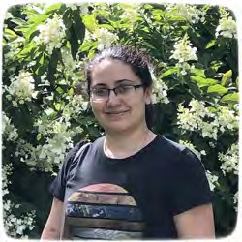
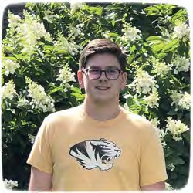
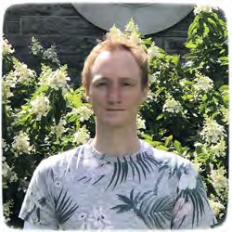
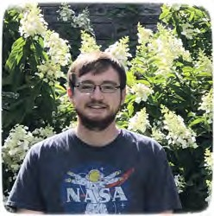

Dallar Babaian
Calif State Univ Northridge
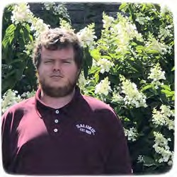

Brett (Allen) McCarty
Southern Illinois University

Dillon Balthrop
Murray State University
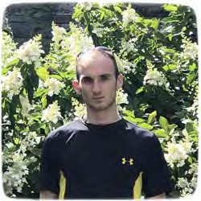

Maxwell Metter
University of Missouri Columbia

David Beckwitt
Missouri State University
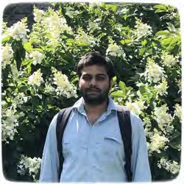

Moudip Nandi
Missouri State University

Clayton Conner
Eastern Illinois University
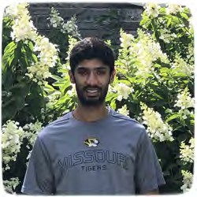

Deepesh Sigdel
Southeastern Louisiana Univ

Not pictured: Bangzheng Sun, University of Wisconsin Madison
Alumni Losses
We are sad to report the deaths of these alumni over the past year.

James Casteel died of colon cancer on October 2, 2019. Jim was a graduate student in the department for several years in the late seventies and early eighties.

Katherine Blacklock passed away unexpectedly on November 12, 2019. Kate graduated from the department with her PhD in Physics in 1978 was was the first female graduate student to receive a PhD from the department. She worked at Lockheed‐Martin in Denver, where she became a senior staff engineer working with launch systems until her retirement.

Jagat Lamsal passed away in Rolla, Missouri on Tuesday, August 4, 2020. He graduated from the department with his PhD in 2011. Jagat did Post‐Doctorate research at Iowa State University in Ames, Iowa, and taught at the Moberly Area Community College in Columbia. He was also a Visiting Scholar at the Research Reactor at the University of Missouri in Columbia. Jagat was born in Syangja, Nepal and had a passion for helping international students.

John Gordon passed away on April 19, 2020. He graduated from the department in 1968 with a bachelor’s degree in physics. He was a member of the U.S. Air Force ROTC program at the University and was commissioned as a second lieutenant upon graduation. After 32 years in the U.S. Air Force, John retired in 2000 with the rank of General. He had a illustrious career in the military and government service, including as physicist at the Air Force Weapons Laboratory, Deputy Director of the Central Intelligence Agency; Director of Operations for Air Force Space Command; Commander of the 90th Missile Wing, Senior Director for Policy on the National Security Council at the White House, Undersecretary of the Department of Energy, and as Assistant to the President and Homeland Security Adviser. John was a past physics leader.

Student Support – Thank you, Alumni!

Many fellowships, scholarships, and other funds have generously been established and supported by our alumni. These students were the recipients of these funds and awards for the academic year 2019‐2020 and summer 2020.

UNDERGRADUATE STUDENT SCHOLARSHIPS

Paul E. Basye Undergraduate Scholarship
Myles Moise, Andrew Olds, Justin Shotten, Andrew Tait, Matthew Snyder

Rose Marie Dishman Endowed Scholarship in Physics
Phillip Hegeman, Zach Valleroy, Drake Sivils

Guy Schupp Scholarship Fund
Andrew Tait

O.M. Stewart Scholarship
Nicholas Bohorquez

Melvin Y. Mora Undergraduate Scholarship Fund
Nicholas Bohorquez, Quinn Cunningham

Donald L. and Lona Lewis Packwood Endowed Undergraduate Scholarship Fund in Physics Ian Miller

Clifford W. Tompson Scholarship in Physics
Nicholas Childers, Joshua Miles

GRADUATE STUDENT SCHOLARSHIPS

Horace (Dan) R. Danner Fellowship
Lisa Shepard

Rose Marie Dishman Endowed Scholarship in Physics
Ryan Smith

James L. and Dora D. Fergason Fund for Excellence in Physics
Amarnath Chakraborty, Ehsan Faridi, Teja Teppala, Creighton Lisowski, Nirmal Baishnab, George Yumnam, Mitchel Vaninger

Newell S. Gingrich Physics Scholarship Fund
John Barron, Payal Bhattacharya, Aditya Putatunda, Sean Fayfar

Newell S. Gingrich Physics and Astronomy Endowment
Vishal Jayswal, Jiasen Guo, Erica Hroblak

Eli Stuart Haynes and Nola Anderson Haynes Scholarship Fund
Lisa Shepard

Eugene B. Hensley Scholarship in Physics
Dylan Weaver

Ernest W. Landen Fellowship in Physics
Chenxioji Ling

O. M. Stewart Scholarship
Mari Tsumuraya, Pratik Sahu, Alex Bretana, Ehsan Faridi, Amarnath Chakraborty, Todd Lombardi, Pousali Ghosh, Alex Daykin, Charles Mentzer, Ryan Smith, James Jones, Zhenfei Jiang

H. Phillip Graduate Fellowship
Lisa Shepard

Guy Schupp Scholarship Fund
John Barron

William E. Spicer Fund for the Development of Excellence in Physics
Dylan Weaver

GRADUATE AWARDS

Carl & Brynn Anderson Graduate Student Award Fund in Physics (travel support)
Katie Schaefer, Jacob Cook, Qiangsheng Lu

Ron Boain and Catherine Rangel‐Boain Dissertation Award
Anna Pittmann, James Torres

Ron Boain and Catherine Rangel‐Boain Travel Award Matthew Anderson, Payal Bhattacharya, Randy Burns, Quinn Cunningham, Aditya Putatunda, Lisa Shepard

Gerald Fishman Travel Award
John Barron, Pratik Sahu, Lisa Shepard

Harry E. Hammond Teaching Assistant Award
Todd Lombadi, Mitchel Vaninger

Faculty Updates

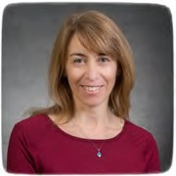



Silvia Bompadre was promoted to Associate Teaching Professor of Physics and Astronomy. Dr. Bompadre continues to serve as our Director of Undergraduate Studies.

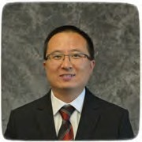

Yicheng Guo was awarded a two‐year grant ($260k) by NASA's Astrophysics Data Analysis Program (ADAP) to study "Bursty or Not: Uncovering the Timescale, Strength, and Effects of Star Formation Episodes in Distant Low‐mass Galaxies". Postdoctoral student John Pharo has joined Guo's group to work on this project. Guo is a co‐PI of a cooperative proposal ("Building Diversity Through Research Internships") approved by NASA‐Missouri Space Grant Consortium. With this proposal (PI: Zaichun (Frank) Feng, Department of Mechanical and Aerospace Engineering), Mizzou is awarded $47,000 per year for four years (total $188,000, 2020‐2024) to support fellowships and internships for graduate and undergraduate students. Junior physics major, Lauryn Williams, supervised by Guo to work on "Identifying and Studying Extremely Young Galaxies in the Universe", was awarded the competitive MARC/IMSD fellowship, which is funded by the National Institutes of Health (NIH) to
Suchi Guha’s research group had a productive year (2019‐2020) with more than 10 publications in the areas of organic electronics and halide perovskites.
Alec Pickett, who worked on hybrid photodetectors, defended his PhD in Dec. 2019 and joined Intel Inc. Guha gave a series of lectures at the 5th South African 2019 and joined Intel Inc. Guha gave a series of lectures at the 5th South African Nanoscience and Nanotechnology Summer School, Cape Town, South Africa in Nov. 2019. She and Ping Yu have completed the setup of an ultrafast laser laboratory, which was funded by an MRI award from the National Science Foundation. This new laboratory has capabilities for nonlinear optics and time‐resolved spectroscopy. Guha and Gavin King organized an NSF sponsored Midscale Research Infrastructure Workshop (Aug. 5‐7, 2020) at MU. The title of the workshop was: “Precision Nanoscale Patterning and Characterization – From Cybernetic Proteins to Nanoengineered Quantum Devices".
Gavin King was promoted to Professor of Physics and Astronomy. In other news, the King lab has recently said “farewell” to Kanokporn Chattrakun (nickname “Tu”), who received a PhD in spring 2020. For her postdoctoral research Dr. Chattrakun has joined another recent King lab graduate (Dr. Anna Pittman, PhD 2019) at St. Jude Children’s Research Hospital. In other news, the King lab has recently started a collaboration with a group from the Biochemistry Department at the University of Tennessee to study the mechanism of action of pore forming peptides. These small proteins spontaneously insert into membranes and cause uncontrolled leakage, an activity that has potential applications in the pharmaceutical arena. Additionally, King co‐organized (with Prof. Suchi Guha) an NSF sponsored workshop on ice lithography, a novel approach to high precision patterning. The workshop, which was 100% virtual due to the pandemic, was highly successful with
>90 individuals from the US and Europe attending.

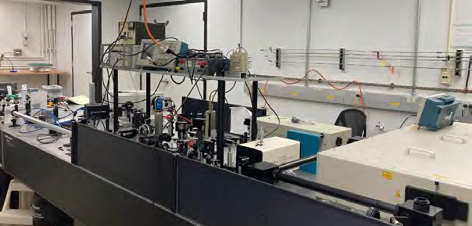
encourage underrepresented minority students to pursue a career in STEM.
Our 2019 newsletter reported that Suchi Guha and Ping Yu received a Major Research
Instrumentation award from the National Science Foundation (NSF) for an amplified laser system that will facilitate research in condensed matter physics, material science and engineering, chemistry, chemical engineering, biology, bioengineering, and medicine. One year later the lab is up and running and being used by our professors and graduate students.

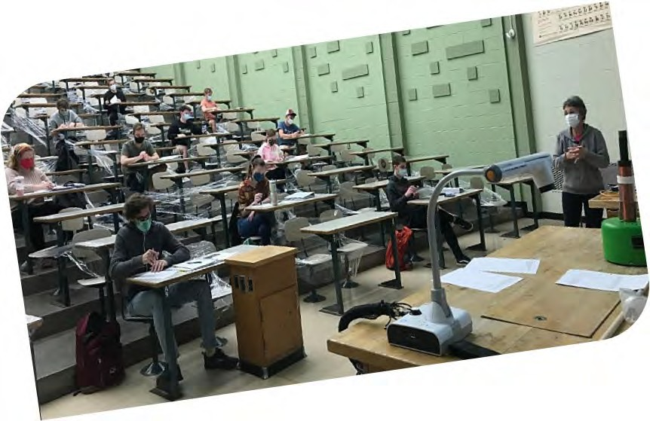
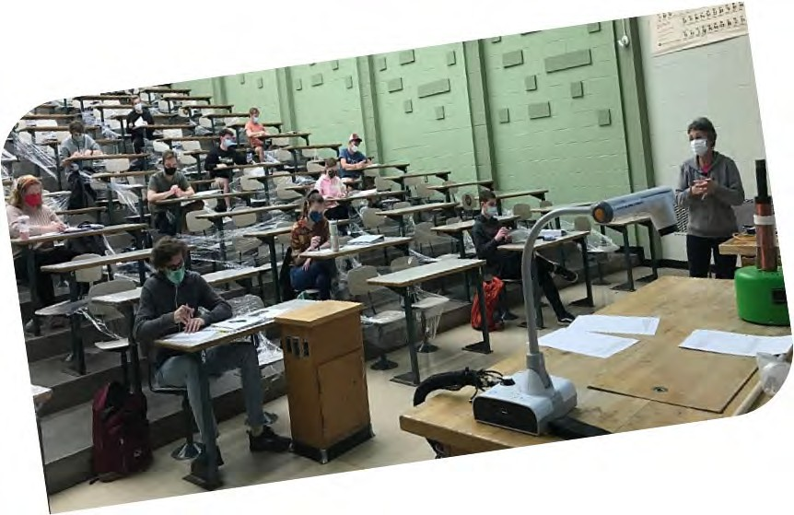
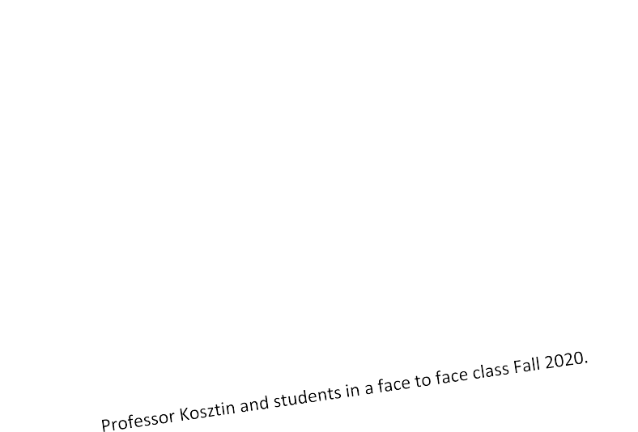
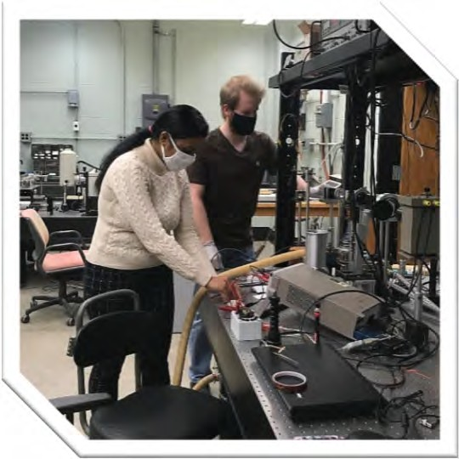



Faculty Updates (continued)

Graduate students Payal Bhattacharya and John Barron follow the safety rules when working in Prof. Guha's lab.
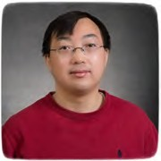
Aigen Li, professor of astrophysics, published an invited review article in Nature Astronomy, entitled "Spitzer's perspective of polycyclic aromatic hydrocarbons in galaxies”.
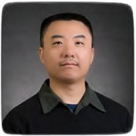
Haojing Yan has been busy working with his collaborators to prepare for their Guaranteed Time Observations at the James Webb Space Telescope (JWST), the next flagship mission of NASA to be launched on October 31, 2021. This is a program that they have been waiting for more than 17 years. JWST is considered as the successor of Hubble Space Telescope and Spitzer Space Telescope. On a parallel path, Yan has been collaborating with Dr. Mattia Vaccari and his team at University of Western Cape (UWC), South Africa to use MeerKAT, the cutting‐edge radio telescope and a pathfinder to the Square Kilometer Array (SKA), to carry out a deep radio survey in the historical Akari Deep Field South (ADFS). Sixteen hours of observations were awarded and executed, and the initial results are already every encouraging. A new proposal has been submitted to request more observations.

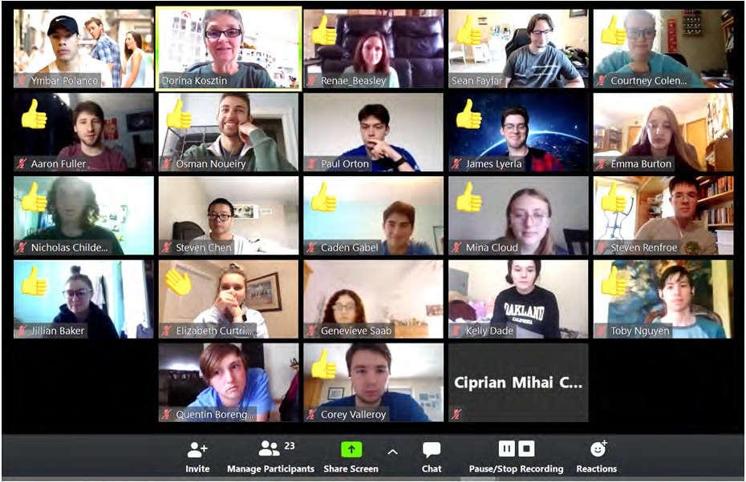
Using “think‐pair‐share” on zoom in Physics 2760 Honors class. Faculty and students found ways to teach/learn despite challenges.

Physics Leaders Meeting
Fall 2019

The physics leaders met on November 8 and 9, 2019 with department Chair Sashi Satpathy, other faculty, and students. Dr. Satpathy along with other faculty provided department updates and accomplishments from the past year. Highlights were Dr. John Shumway talked with students and faculty about his career path and experiences working at Google and the leaders shared their career paths and encouraged Q&A with our students. Three undergraduate and 5 graduate students gave brief but outstanding presentations about their research. A&S Dean Pat Okker spent time with the alumni, faculty, and students.

The evening dinner was held at the Stoney Creek Inn. Following the meal, Dr. Sashi Sitpathy and Leaders president Dr. Vann Priest presented the Faculty Enhancement Awards to Dr. Dorina Kosztin and Dr. Carsten Ulrich. The undergraduate student presentation award was presented to Zachery Vallery and the graduate student presentation award went to Katie Schaefer. Dr. Satpathy, along with Ronald Boain and Catherine Rangel-Boain
presented the Boain Dissertation Award for best doctoral dissertations to Anna Pittmann and James Torres.
A highlight of Friday evening was the presentation of the department Distinguished Alumni Award to Dr. Jerry Fishman for his career achievements in high‐energy astrophysics.
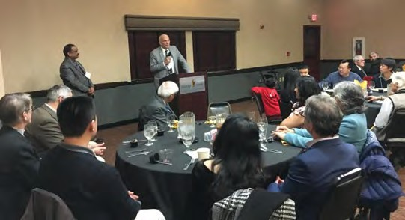
Dr. Jerry Fishman speaking at the Friday evening dinner.

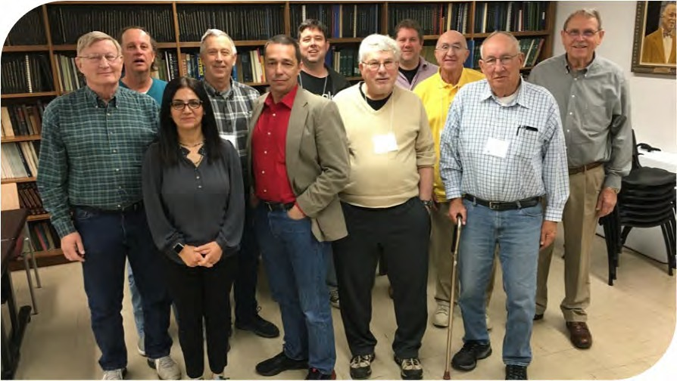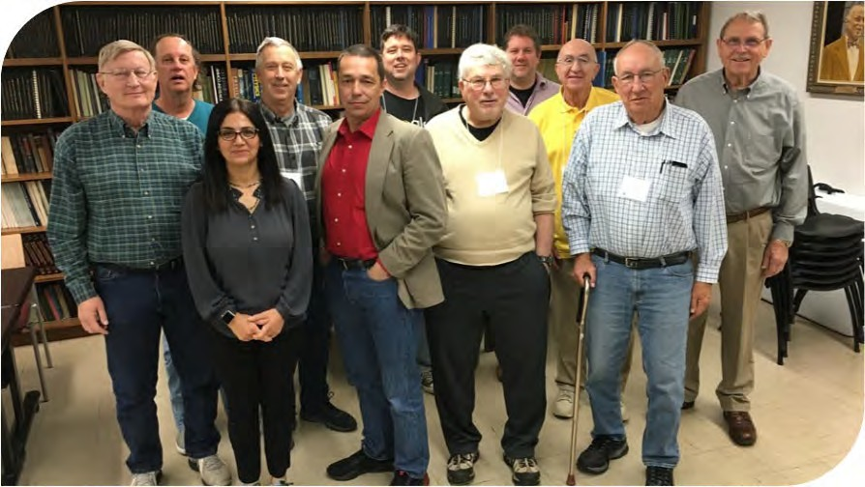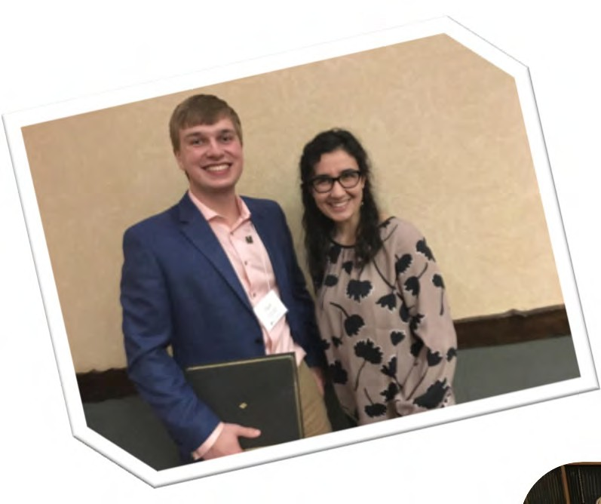
Student presentation award winners

Zachary Valleroy , who spoke on “Hydrocarbon Adsorption in Nanoporous Materials“

Katie Schaefer, who spoke on “Direct Observation of Ligand‐ Induced Conformational Changes of P‐ Glycoprotein In AFM And Correlation With Surface Absorbed Activity Measurements”.

Leaders President Dr. Vann Priest and Professor Sashi Satpathy presented the awards.
Physics Leaders

Front: Philip Chumbley, Shadi Shahedipour‐ Sandvik, Alan Van Nevel, Ronald Boain, John Bodganor

Back: Vann Priest, Carl Anderson, John Shumway, Bruce Bolen, Robert Cunningham, Henry White

Department of Physics and Astronomy University of Missouri

Communiqué is published annually by the Department of Physics and Astronomy at the University of Missouri.

Editorial Office
Department of Physics and Astronomy 223 Physics Building
Columbia, MO 65211 Phone: 573‐882‐3335
E‐mail: umcasphysics@missouri.edu Web site: https://physics.missouri.edu

Editorial Board Linda Godwin Dorina Kosztin Paul Miceli

The department appreciates hearing from alumni and friends. Send announcements or milestones to the address listed above.
223 Physics Building
Columbia, MO 65211

Beginning Fall 2021 we will transition to an e‐newsletter (email) only.
Please contact us by email or phone to provide an email address! umcasphysics@missouri.edu
573‐882‐3335

Recent Faculty Publications list with links to articles can be found at: https://physics.missouri.edu/pubs

Department news: https://physics.missouri.edu/news

Alumni: Please visit https://physics.missouri.edu/alumni‐and‐friends to find how to update your contact information or submit an online profile which will be added to the page.

